Sophie Dunfield

W0246905

Prog2007 Polling System

User Guide

Contents

Use of this Document 2

Introduction 3

1.1 Document purpose 3

1.2 Points of Contact 3

1.3 Glossary 3

Structures 4

Admin Panel 4

Polling Officer Panel 5

Voters Panel 5

Problems & Solutions 6

Admin 6

Polling Officer 6

System Flow Chart 7

Sample Scenario 8

Test Cases 12

Bibliography 14

# Use of this Document

This document is meant as a guide in explaining various aspects of the ‘Prog2007 Polling machine’ system. Please refer to the quick reference table of contents to explore the document and figure there in by pressing the control key and select the section you wish to visit.

This project is being produced in concert with a System analyse project, and a T-SQL project for educational purposes and therefore is not meant to be used in anyway outside of the scope of the NSCC IT-Programming course. If you have received a copy of this program, or any involved documents, please be advised that the author of any of these items is not liable for any damages incurred from the use of these systems. And reproduction, or distribution of any of these documents requires express condition for the author and must be labelled properly as ‘for educational use only’.

This document will be referring several aspects not included in the document itself by citation to the proper document, or by images of documents of programs. Please see the bibliography at the end of the document for information on the referenced documents. In addition, the systems being used in this document, including that of the ‘IntelliJ CLion’ IDE (integrated development environment), the Microsoft MYSQL Server Management Studio 18, and Microsoft Visio will be added with their website will be linked in the bibliography.

The information in this document will serve to address a few specific areas of interest to the learning outcomes of the Prog2007 course, including but not limited to user documents, testing and programming in the ‘c’ language. For more information on any given section, please see the introduction at the beginning of the section.

In addition to this information please be advised that this is a terminal program and there exists *sans* GUI (graphical user interface). This system is not secured against tampering, being only a shell to show the process and is therefore able to be manipulated.

# Introduction

## 1.1 Document purpose

Congratulations, you have come into possession of our Prog2007 polling system. Now the question is of course, how can we make use of this technology. This guide is intended to be a step-by-step guide to setting up and starting you first election simulation. It consists of a few easy-to-understand paths and some simple structures to hold the information.

In addition to the documentation, you will find a glossary of terms at the end of the section explaining several terms and acronyms that are necessary to the understanding of this, and the other two documents being made for the purposes of this system. These glossaries are universal between documents to allow you to revisit and review words where needed.

## 1.2 Points of Contact

|  |  |  |  |
| --- | --- | --- | --- |
| Role | Name | Email | Telephone(fake number) |
| System Designer | Sophie Dunfield | W0246905@campus.nsccc.ca | (902)-867-5309 |
| System Analyst | Sophie Dunfield | W0246905@campus.nsccc.ca | (902)-867-5309 |
| Application Developer | Sophie Dunfield | W0246905@campus.nsccc.ca | (902)-867-5309 |
| Data Manager | Sophie Dunfield | W0246905@campus.nsccc.ca | (902)-867-5309 |

## 1.3 Glossary

|  |  |  |  |
| --- | --- | --- | --- |
| Abbreviation | Term | Abbreviation | Term |
| DOB | Date of birth | ID | Identification |
| Admin | Administrator | IT | information technology |
| RO | returning officer | SQL | Structured Query Language |
| DO | Deputy Officer | TSQL | TSQL – Transaction SQL (see SQL) |
| SO | supervising officer | DML | Data Manipulation language |
| UML | Unified Modeling Language | DCL | Data control language |
| SWOT | Strength, Weakness, Opportunity Threat | SSMS | SQL server management studio |
| MS | Microsoft |
| SDLC | Software Development life cycle | SDD | System Design documentation |
| DDD | Database Design Document |
| SAAD | Software Analysis and Design | HRM | Halifax regional Municipality |
|  |  |

## Structures

1. The first structure in this program is the voter, this will be the people who input their votes into the system. A voter consists of; a first name, a last name, an integer registration number, an integer-based date of birth (DoB – written as yyyymmdd) and a Boolean value which signifies whether or not the voter has cast their ballot yet.
2. The second structure is the admin structure. This will be the person who sets up the system. The admin has to be assigned before anything else can be done in the system. The admins’ sole duty is to assign the polling officers. There is only allowed to be one admin. The admin structure consists of an adminID, a loginID and password.
3. The third structure in the system is that of the polling officer. This works in much the same way as a polling officer does in a real election, with the exception that there is no distinction between the levels or officer. They will be the ones to set up candidates in the system, to enter voter information and to fix voter information where needed, and to declare the results of the election.

The polling officer is made up of an officerID which is automatically assigned, a first name, a last name, and a password. The polling officer uses their first name, last name, and a password to sign in. There is a limit to 3 (three) polling officers in this system, with the intention of a returning officer (RO), a deputy officer (DO) and a supervising officer (SO).

1. The final structure in this program is the candidate structure. This represents the people being voted for, and is made up of a candidateID, a first name, a last name, and an integer to store the number of votes that the candidate has received.

More information will be given into this set up in the use case diagrams and workflow diagrams in the following section. You may also want to refer to the System Design documents for more information on the system where this document skips through it.

The next sections of this document will revolve largely around the use of this system and test scenarios to show the workings on the system. All the images and inputs are taking directly from the system.

# Admin Panel

Upon start up you will be forced to go to the admin panel, this is setup to not allow you to proceed until the admin has been setup. Upon starting the program, enter (1) in the next entry enter (2). This will allow you to set the admin Id and password. It is important to note that the Id is limited to 50 characters (alpha-numeric) and the password is limited to 16 characters (alpha-numeric). Be sure you write down your username and password, if these are forgotten you will have to restart the system.

Upon entering the admin section, you have options to (1) Enter polling officers (2) cancel. When entering a polling officer, you will be prompted to enter their first name, last name, and a password. These are used to log into the polling officer section, so be sure to have these written down for the officers who will be using the system. The (2) cancel will bring you back to the welcome section.

# Polling Officer Panel

Once you have the system and polling officers set up, you can enter into the officer section. In the Officer section, you are prompted to enter your first name, last name, and password. These will check and will allow you to log in if all three matches. In this section you have 5 options; (1) register voter, (2) add candidate (3) declare election results (4) fix voter information (5) cancel.

1. Register voter allows you to input the voter’s name (first and last), their date of birth, and their registration number which you will find on their voting card. They require a valid registration number to be allowed to cast a ballot.
2. Add Candidate allows you to add all candidates running in the election. There is a limit of 5 candidates in this system. You will be prompted to enter their first and last name.
3. Declare results will end the session, and generate the outcome based on the amount of votes each candidate has received. It will also output the candidate with the most votes. PLEASE NOTE, declaring the results will prompt you for a yes or no before proceeding. If the election time has not elapsed, you should not end the vote.
4. Fix voter information allows you to enter the appropriate voter registration number and change information about the voter, such as first name, last name, and birth date. Changing a voter’s information also ensures that the flag for whether they have voted is false, allowing them to cast a vote in cases of stolen registration numbers or duplicate numbers being assigned.
5. The cancel button will bring you back to the welcome section.

# Voters Panel

Finally, having set up the voters for your system, they may cast their vote. They will be greeted by the welcome screen and asked to enter their registration number. The system will then loop through all the valid registration numbers you have entered and will find the appropriate voter. If there are no matching registration numbers, they will receive the message ‘This registration number doesn’t exist in the system. Please see polling officer to correct this.’

If these is a valid registration number matching that of the voter, the next thing the system does is to check whether or not the system has already received a vote from this voter. Upon adding every voter, they are assigned with a flag that represents whether they have voted in the system. Upon casting a vote, it becomes ‘true’. If the voter has already cast a vote, they will receive the message, ‘A vote has already been cast by this user. If you have not cast a vote, please see the polling officer.’

If both these checks have been passed, they are prompted to verify their date of birth. This allows them to ensure that they are the correct person without giving personal information of other voters away. If they select that it is not the correct age, they will receive the message ‘There has been a mistake as your age is incorrect, please see polling officer to fix this.’ If they select that it is their age, the system checks the age against the current year to determine whether the voter is of legal age to cast a vote. If they are younger than 18 years of age, they receive a message saying ‘The has been a mistake as you are under the age of voting. Please see the polling officer to confirm your date of birth.’

If all these checks are passed, the system outputs the candidate names and allowed the voter to cast their vote. This vote is stored as a simple integer with no reference to voter for security and legal reason.

# Problems & Solutions

## Admin

|  |  |
| --- | --- |
| System problem | Know solution |
| Admin login Failure after setup | Restart system – This will be starting from blank. Write down the password next time. |
| PO login failure(less than 3 officers entered) | Add a new officer with the right credentials |
| PO login failure(3 officers entered) | When you reach 3 polling officers it will prompt you to replace officers instead of adding them |

## Polling Officer

|  |  |
| --- | --- |
| System problem | Know solution |
| Polling officer login fail | See Admin to confirm and reset name and password |
| “Under the age of voting message” for user trying to vote | Confirm their age, if they are underage, they are no eligible to vote. If age is incorrect use ‘fix voter information’ option to change their age. |
| “Incorrect age” message for user trying to vote | The voter has selected that the age in the system is not correct. Use ‘fix voter information’ option to change their age. |
| “A vote has already been cast by user” message for user trying to vote | The user has either already voted, which should be demonstrated on your voter check-in sheets, or the wrong registration number was given to a voter. Use the Use ‘fix voter information ‘option to and re-enter their information. This will allow a vote to be cast by this user. Proceed to fill out paperwork to indicate the issue and provide this information to the poll supervisor |
| “This registration number doesn’t exist in the system” message for user trying to vote | Voter information may have been entered incorrectly, or they may have entered the registration number incorrectly. Confirm the registration number on their voter card and re-enter information in the ‘fix voter information’ section. |

# System Flow Chart

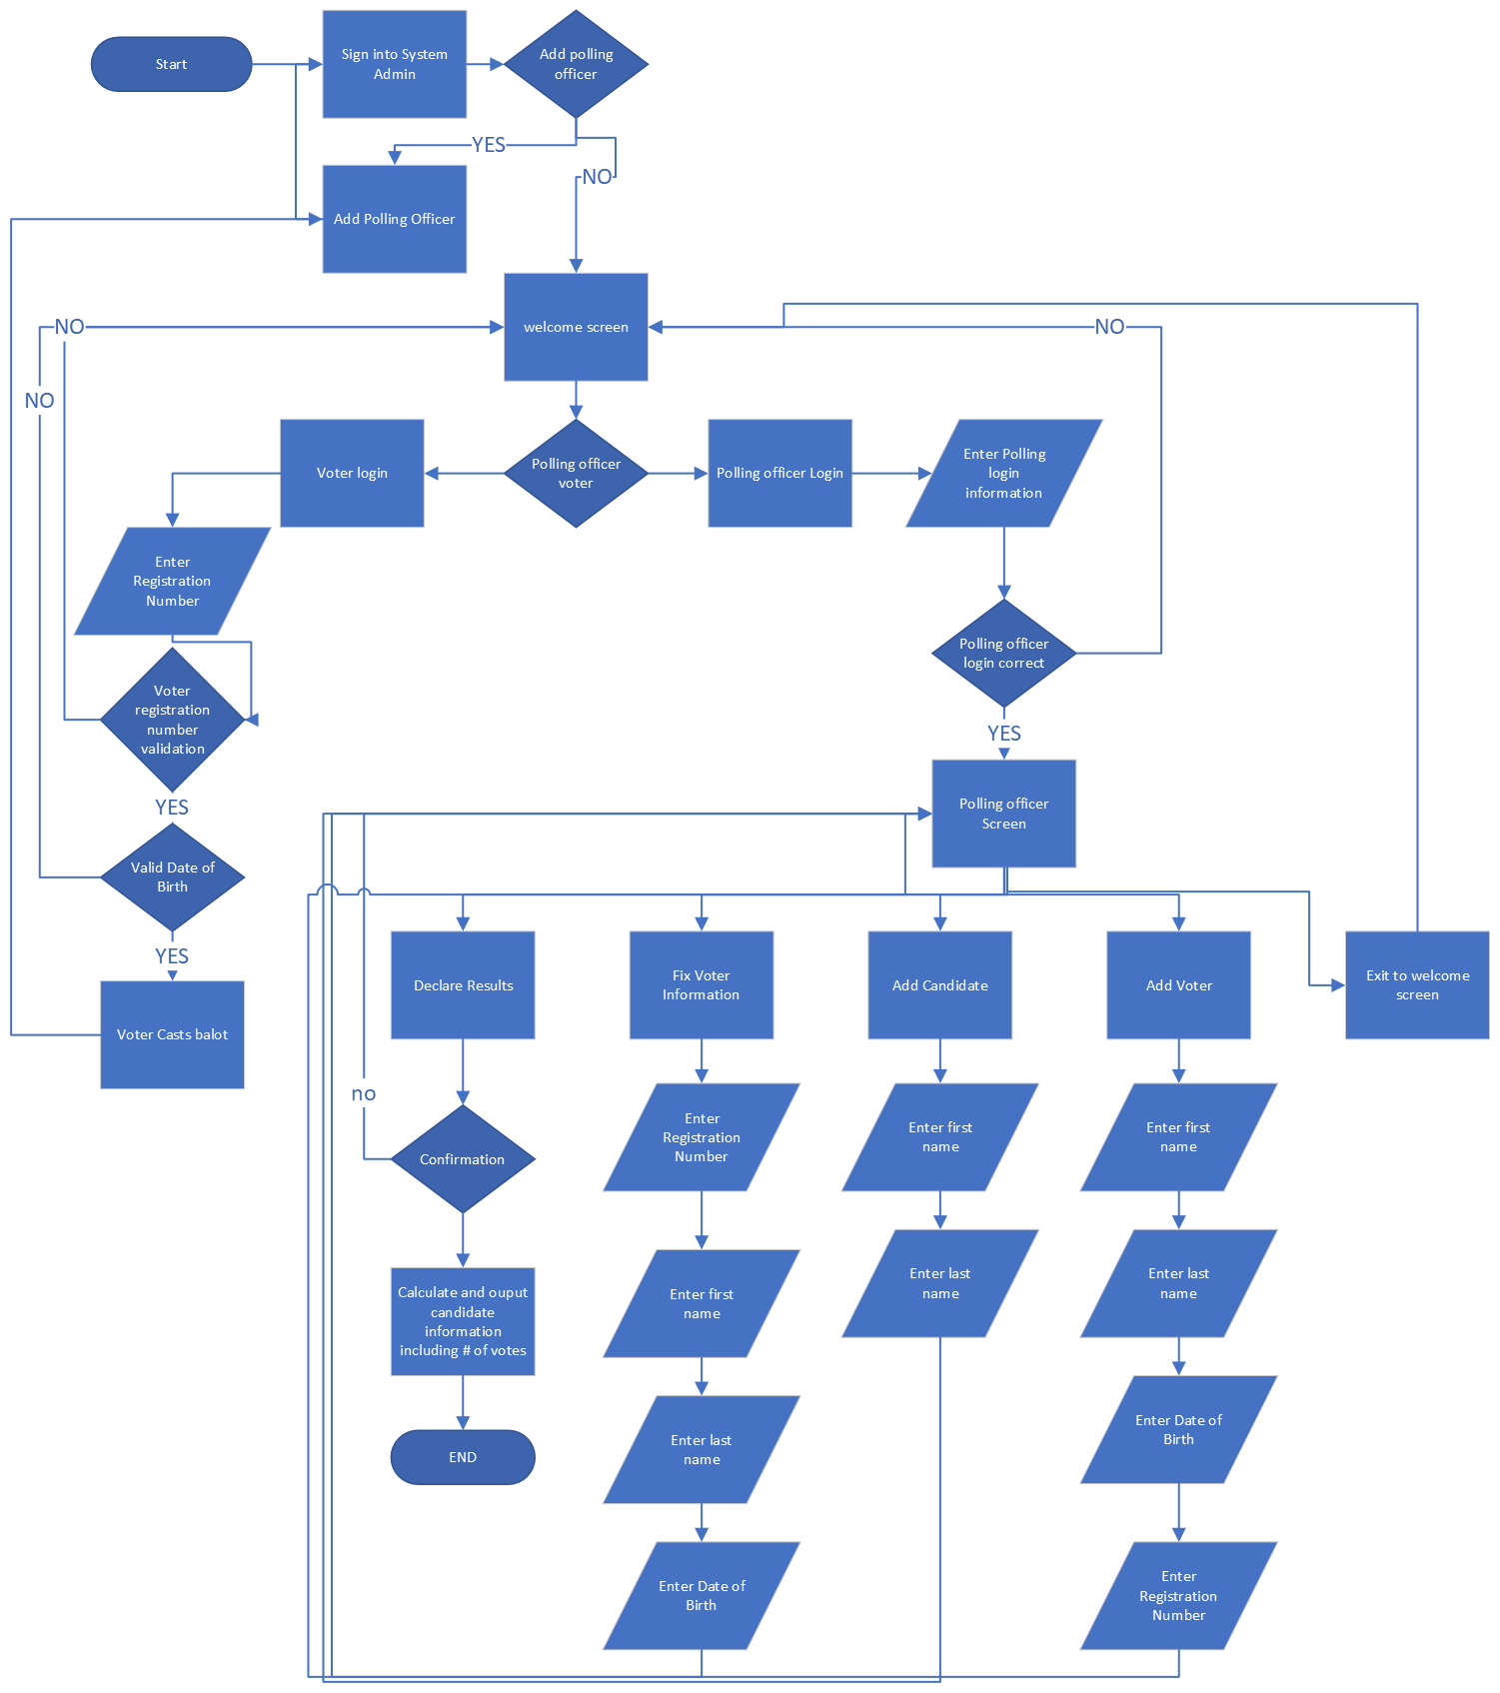

# Sample Scenario

**System Admin:**

**AdminId**: admin123

**Password:** sdffdsdf23

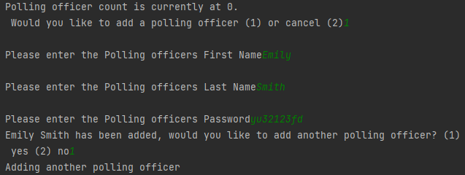

**Polling Officers:**

**First Name:** Emily

**Last Name:** Smith

**Password:** yu32123fd

**First Name:** Brian

**Last Name:** Melson

**Password:** sdf2332dfs

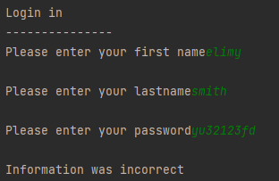

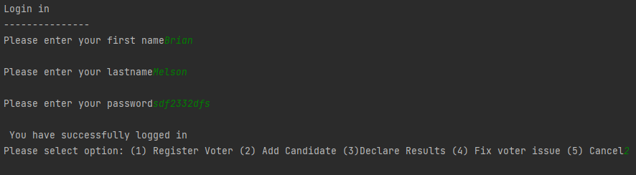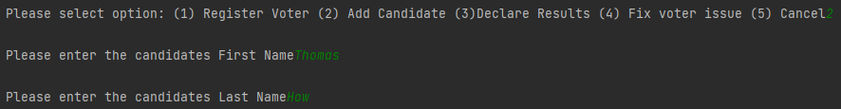

**Candidates:**

**First Name:** Thomas

**Last Name:** How

**First Name:** Robert

**Last Name:** Bobertson

**First Name:** Emeret

**Last Name:** Clance

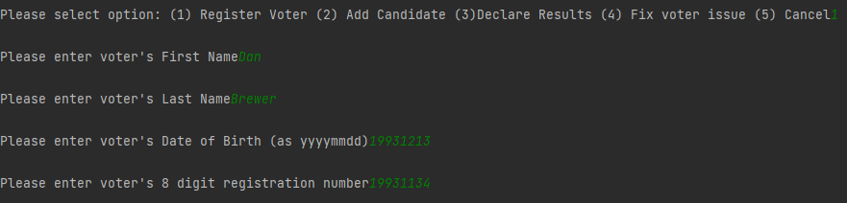

**Voters:**

**Registration Number:** 19931134

**First Name:** Dan

**Last Name:** Brewer

**Date of Birth:** 1993-12-13

**Registration Number:** 12355632

**First Name:** Benjamin

**Last Name:** Brown

**Date of Birth:** 2001-11-04

**Registration Number:** 12399423

**First Name:** Steve

**Last Name:** Stevens

**Date of Birth:** 2007-10-13

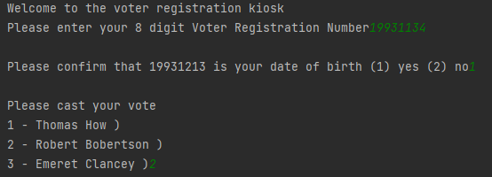



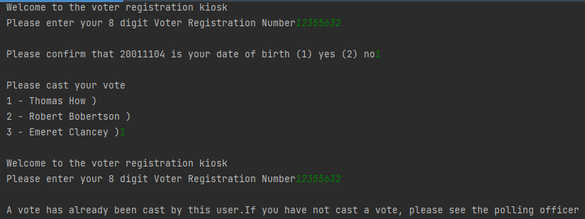

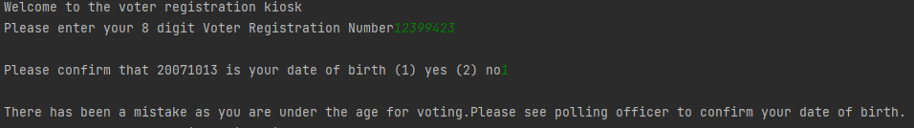

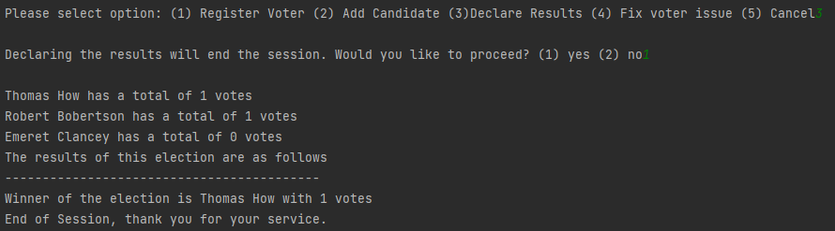

# Test Cases

|  |  |  |  |  |  |  |  |
| --- | --- | --- | --- | --- | --- | --- | --- |
| PROJECT NAME: | | | | PROG2007 Polling Station | | | |
| MODULE NAME: | | | | Login | | | |
| REFERENCE DOCUMENTS: | | | | System design Document | | | |
| CREATED BY: | | | | Sophie Dunfield | | | |
| DATE OF CREATION: | | | | March 2023 | | | |
| Test Scenario | Test Case | Pre-Condition | Test Steps | | Test data | Results | Past  Fail |
| Admin Login | Valid ID and Password | Need a valid admin | 1) Enter username | | Valid username valid password | Logged in | P |
| 2) Enter password | |
| Admin Login | Valid ID and Password | Need a valid admin | 1) Enter username | | Valid username invalid password | Logged Failed | P |
| 2) Enter password | |
| Admin Login | Valid ID and Password | Need a valid admin | 1) Enter username | | Invalid username valid password | Logged Failed | P |
| 2) Enter password | |
| Admin Login | Valid ID and Password | Need a valid admin | 1) Enter username | | Invalid username Invalid password | Logged Failed | P |
| 2) Enter password | |
| - All admin tests passed, Admin validation is functioning properly and is accurate. | | | | | | | |
| Test Scenario | Test Case | Pre-Condition | Test Steps | | Test data | Results | Past  Fail |
| PO Login | Valid Fname, Lname and Password | Need a valid polling officer | 1) Enter First Name | | Valid First Name  Valid Last Name  Valid Password | Logged success | P |
| 2) Enter Last Name | |
| 3) Enter password | |
| PO Login | Valid Fname, Lname  invalid Password | Need a valid polling officer | 1) Enter First Name | | Valid First Name  Valid Last Name  Invalid Password | Logged Failed | P |
| 2) Enter Last Name | |
| 3) Enter password | |
| PO Login | Invalid Fname, valid Lname and Password | Need a valid polling officer | 1) Enter First Name | | Invalid First Name  Valid Last Name  Valid Password | Logged Failed | P |
| 2) Enter Last Name | |
| 3) Enter password | |
| PO Login | Valid Fname, invalid Lname valid Password | Need a valid polling officer | 1) Enter First Name | | Valid First Name  Invalid Last Name  Valid Password | Logged Failed | P |
| 2) Enter Last Name | |
| 3) Enter password | |
| - All polling officers tests passed. All three variables need to be correct to proceed. Validation for polling officers based on admin’s entered information worked as intended. | | | | | | | |
| Test Scenario | Test Case | Pre-Condition | Test Steps | | Test data | Results | Past  Fail |
| Voter login | Valid Registration  Valid date of birth | Need valid voter registration number | 1) Enter Registration number | | Valid registration number  Valid Date of Birth | Login Successful | P |
| 2) Date of birth automatic check | |
| Voter login | Valid Registration  Valid date of birth | Need valid voter registration number | 1) Enter Registration number | | Invalid registration number  Valid Date of Birth | Login Failed | P |
| 2) Date of birth automatic check | |
| Test Scenario | Test Case | Pre-Condition | Test Steps | | Test data | Results | Past  Fail |
| Voter login | Valid Registration  Valid date of birth | Need valid voter registration number | 1) Enter Registration number | | Valid registration number  Invalid Date of Birth | Login Failed | P |
| 2) Date of birth automatic check | |
| - All Voter tests passed. Proper messages were given for the errors encounter i.e. If age was under the voting age is would return a message about the age, but if registration was wrong, it returned message about registration. | | | | | | | |

# Bibliography

Microsoft (n.d.). *Microsoft Visio flowchart Maker*. Retrieved November 4, 2022, from <https://www.microsoft.com/en-ca/microsoft-365/visio/flowchart-software>

Microsoft (n.d.). *Download SQL server management studio*. Retrieved February 11, 2023, from <https://learn.microsoft.com/en-us/sql/ssms/download-sql-server-management-studio-ssms?view=sql-server-ver16>

JetBrains (n.d.). *Clion: A Cross platform IDE for C and C++*. Retrieved January 11, 2023, from <https://www.jetbrains.com/clion/promo/?source=google&medium=cpc&campaign=11960744855&term=clion&content=489240779231&gclid=Cj0KCQjw8e-gBhD0ARIsAJiDsaUYQSzG-T7VDEiNuA-GPM0xvtkfSiO3_M9-CLECwLkwXXkJ9xmuviIaAmL2EALw_wcB>

(n.d.). *DB diagram. Io*. DB Diagram.io. Retrieved February 20, 2023, from <https://dbdiagram.io/home>

Grammarly (n.d.). *Free citation generator*. Retrieved January 15, 2023, from <https://www.grammarly.com/citations>

(n.d.). *GitHub*. GitHub. Retrieved March 20, 2023, from <https://github.com/>

(n.d.). *UML diagram type*. Creately. Retrieved February 21, 2023, from <https://creately.com/blog/diagrams/uml-diagram-types-examples/#ClassDiagram>

Government of Canada (n.d.). Canadian Elections Act. Justice Laws Website. Retrieved January 30, 2023, from <https://laws-lois.justice.gc.ca/eng/acts/e-2.01/>